An Automatic Digital Audio Authentication/Forensics System

In this project author using Gaussian Mixture Model machine learning algorithm to detect given audio is REAL or FORGE, sometime audio can be tamper or record with original audio and then replay that audio in front of authentication system to gain illegal access and to overcome from this problem author using GMM machine learning algorithm with FT (Fourier transformation) feature extraction algorithm to detect such recorded audio or tamper audio.

To implement this project and to train GMM algorithm we have use forge and real audio clips dataset and this dataset saved inside ‘dataset’ folder and below screen showing content of dataset folder

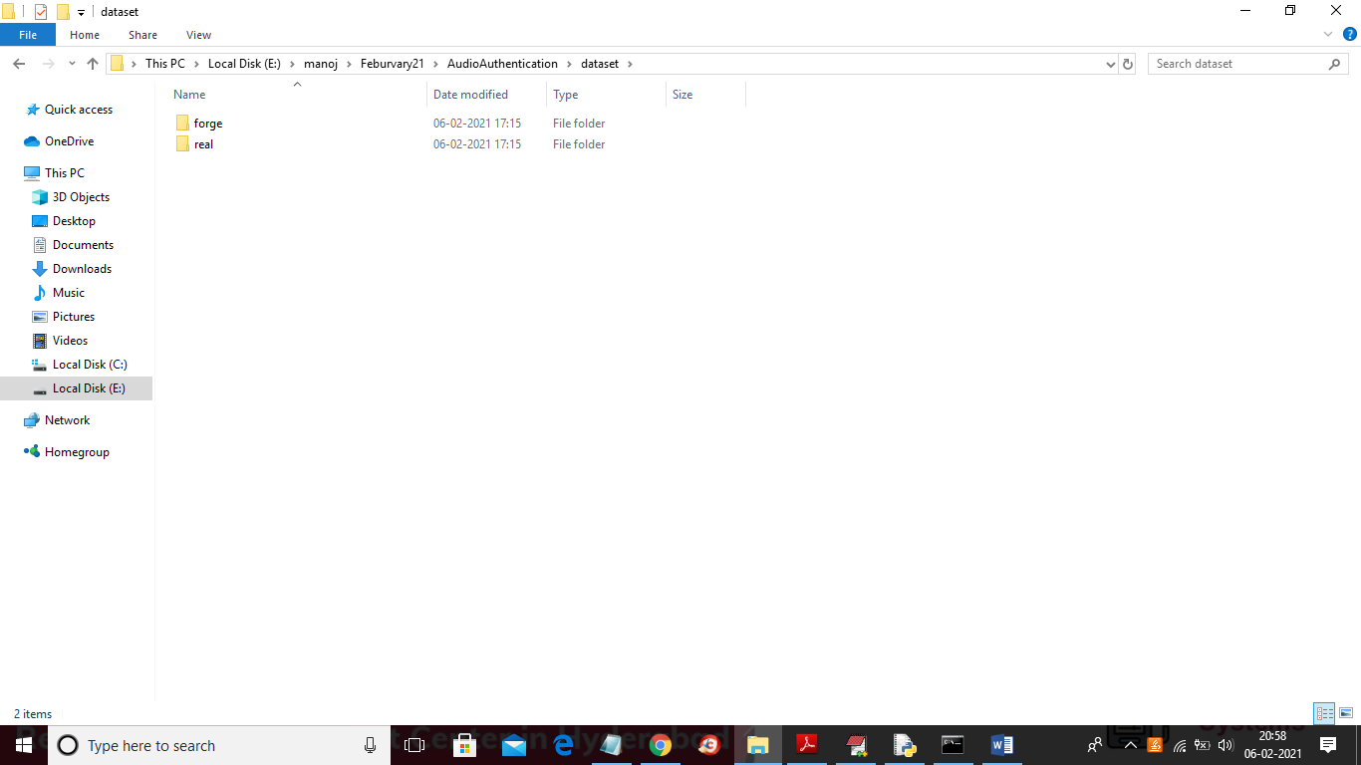

In above screen we have two folders and one folder contains forge audio clips and other folder contains real audio clips and below is the content of forge folder

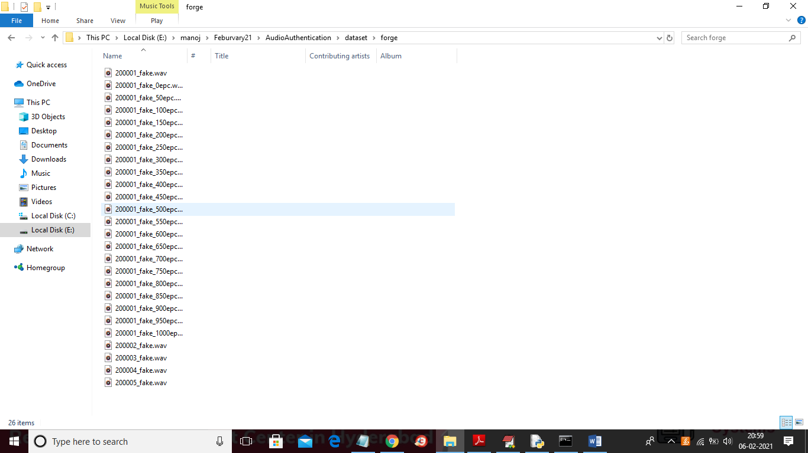

In above screen all audio files saved as .wav format and to implement this project we have designed following modules.

1. Upload Dataset: Using this module we will upload dataset to application
2. Feature Extraction: Using this module we will read each and every audio file and then apply feature extraction algorithm to extract important features from audio file and then split all extracted features into train and test part. Application will use 80% dataset to train GMM and 20% dataset to test GMM and its accuracy.
3. Load & Build Gaussian Mixture Model: Using this module we will train GMM model with above train dataset and then apply test data on trained model to calculate prediction accuracy
4. Audio Authentication: In this module we will upload new audio file and then extract features from that audio file and then apply GMM trained model on that new audio file to predict whether that audio is REAL or FORGE.

SCREEN SHOTS

To run project double click on ‘run.bat’ file to get below screen

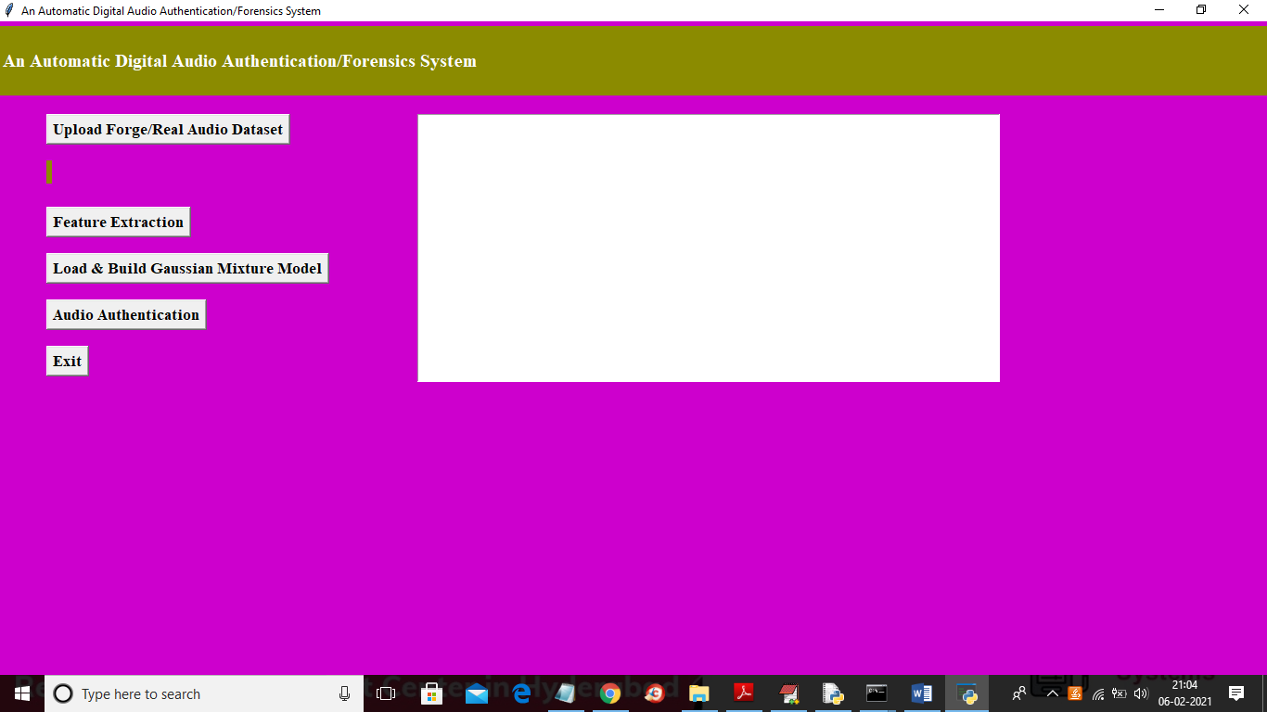

In above screen click on ‘Upload Forge/Real Audio Dataset’ button and then upload dataset folder

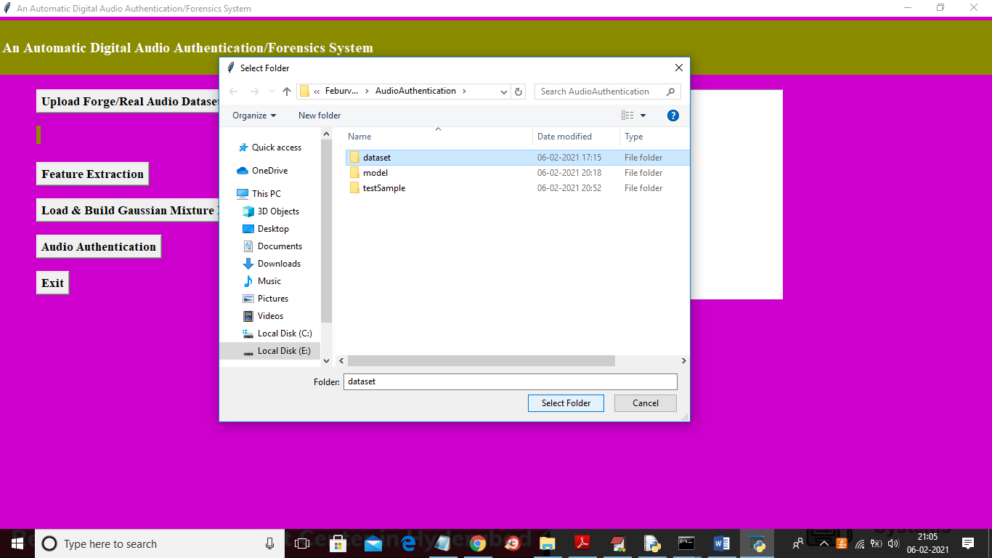

In above screen selecting and uploading ‘dataset’ folder and then click on ‘Select Folder’ button to load dataset and to get below screen

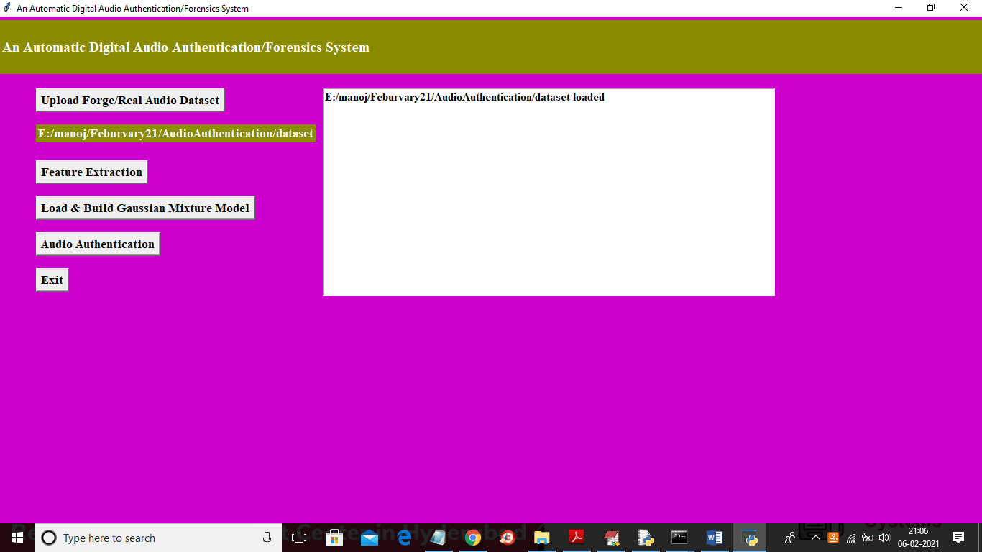

In above screen dataset loaded and then click on ‘Feature Extraction’ button to read audio files and to extract features

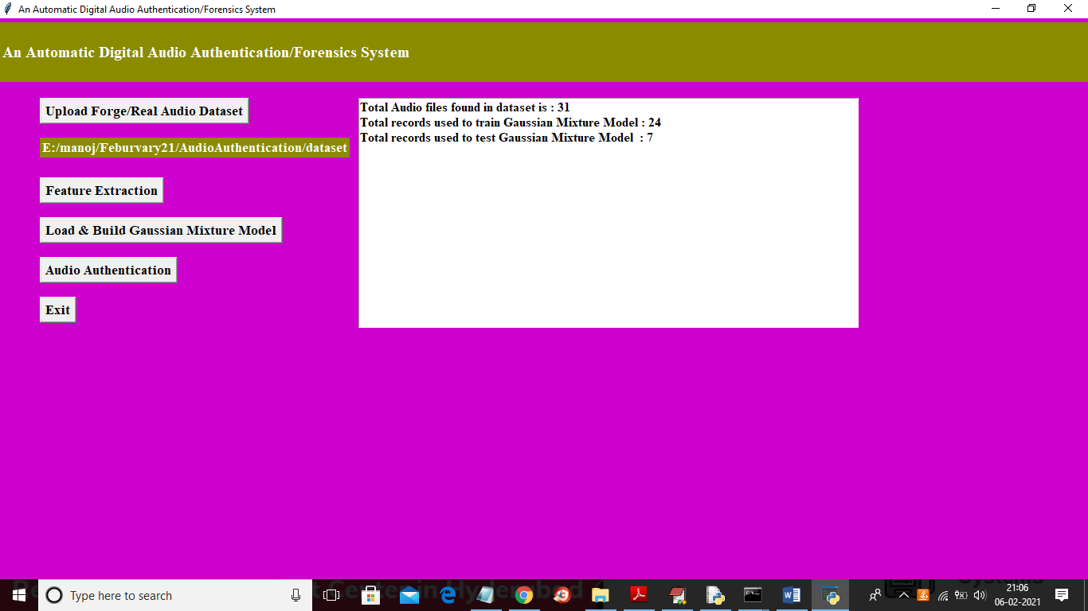

In above screen all audio files features extracted and then application find total 31 audio files and the using 24 files to train GMM and 7 to test GMM. Now dataset ready with train and test records and now click on ‘Load & Build Gaussian Mixture Model’ button to train GMM model and calculate prediction accuracy.

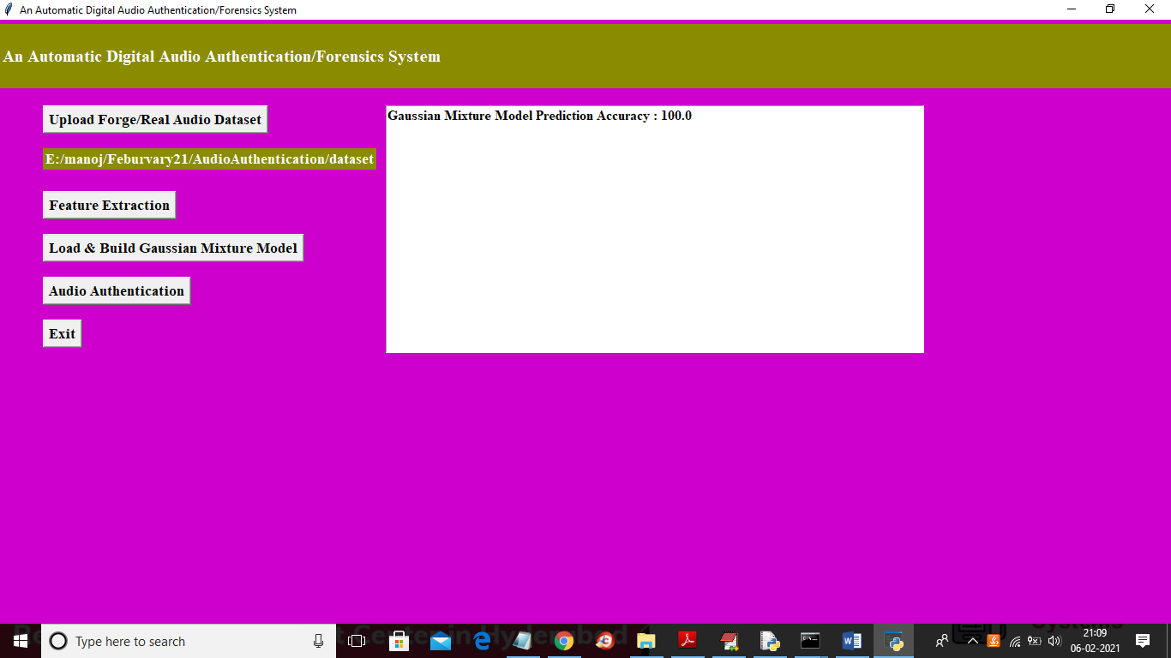

In above screen GMM model generated and its prediction accuracy is 100% on test data and now click on ‘Audio Authentication’ button to upload new test file and perform prediction

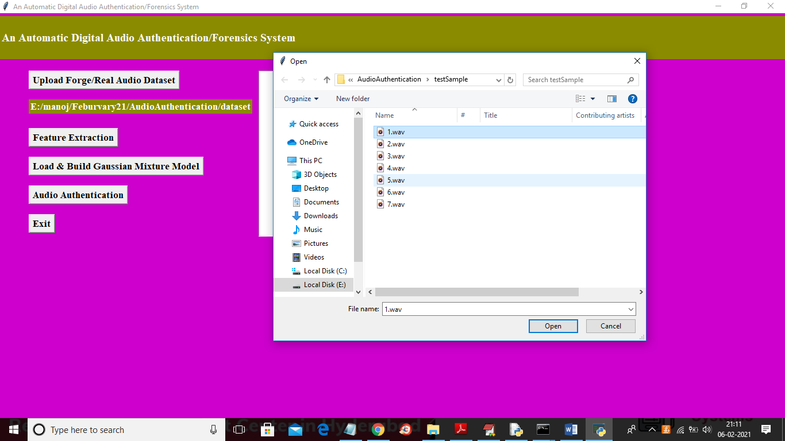

In above screen selecting and uploading ‘1.wav’ file and then click on ‘Open’ button to predict its content

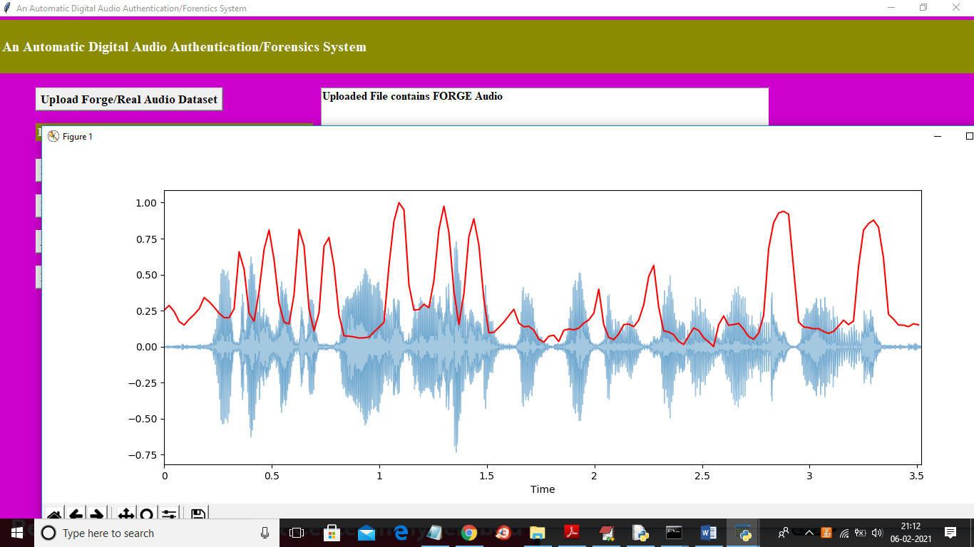

In above screen text area we got predicted result as uploaded file contains ‘FORGE’ audio and then displaying audio features in graph and now test with other file

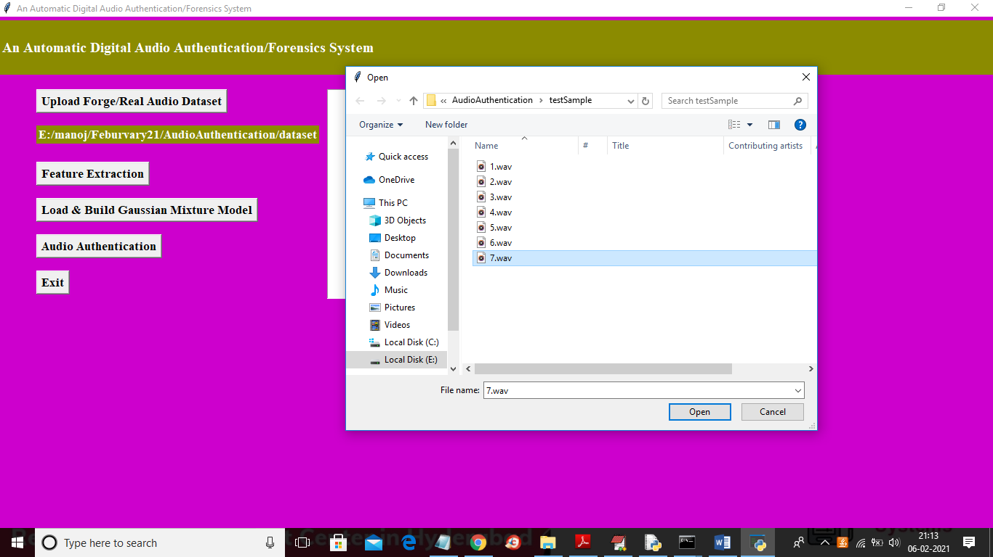

In above screen selecting and uploading ‘7.wav’ file and then click on ‘Open’ button to get below result

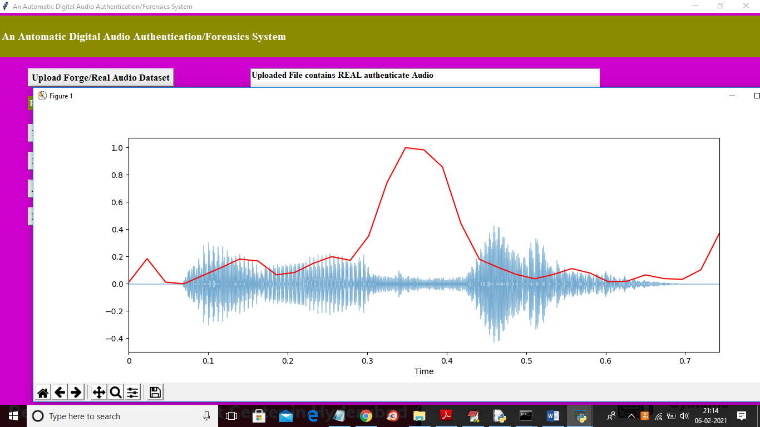

In above screen text area we can see predicted result as ‘uploaded file contains REAL audio’ and you can see difference in above 2 graphs for forge and real. In forge graph due to tamper lots of fluctuation is there in red line and in second graph many fluctuations not there.

Similarly you can upload other files and test